Analyses for Female Participants

# 1. Distributions of Motivational Risk Variables

Figure 1 shows violin plots (and one bar plot) of all distributions and quantiles.

**Figure F1**

*

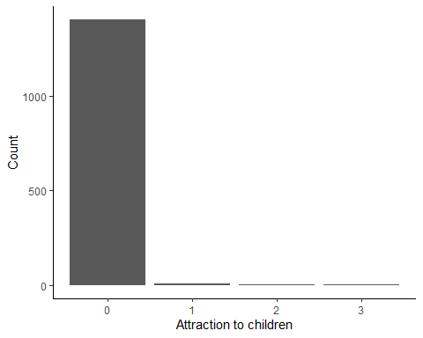

*Note.* As some of the distributions are rather skewed, the variables were split into quantiles for the LCA (except for attraction to children).

Table F1 shows the new descriptives after categorising the variables according to the quantiles.

**Table F1**

*Descriptives for Categorised Motivational Risk Variables*

| Scale | *N* | Categories | Mode | Modal value | *v* |
| --- | --- | --- | --- | --- | --- |
| Attraction to children | 1,420 | 4 | 489 | [0,1] | 0.73 |
| Compulsive sex. | 1,420 | 4 | 396 | (22,28] | 0.75 |
| Loneliness | 1,420 | 4 | 511 | [2,4] | 0.73 |
| Mating effort | 1,420 | 4 | 445 | [3,7] | 0.74 |
| Mate value | 1,420 | 4 | 386 | (16,19] | 0.75 |
| Probl. porn use | 1,420 | 2 | 1,404 | no attraction | 0.02 |
| Sex drive | 1,420 | 2 | 717 | [7,9] | 0.50 |
| Social anxiety | 1,420 | 2 | 862 | [6,7] | 0.48 |

*Note.* Mode refers to how many participants share this modal value. *v* is a measure of variability for categorical variables and refers to the probability that two randomly drawn participants belong to different categories. Round parentheses are exclusive boundaries, square brackets are inclusive boundaries.

# 2. Latent Class Analysis

We redo the LCA with the subset of female participants. The cutoff values for fit indices stay the same. It should be noted that two more variables needed to be dichotomised in the female sample, because they were also to skewed to form quantiles. Those were ‘Probl. Porn use’ and ‘Compulsive sex.’ (see Table F1).

## 2.1 Class Enumeration

Figure F2 shows the BIC values for the different numbers of classes. It is best (i.e. lowest) for three classes, which is the model we choose.

**Figure F2**

*BIC Values for Different Numbers of Classes*

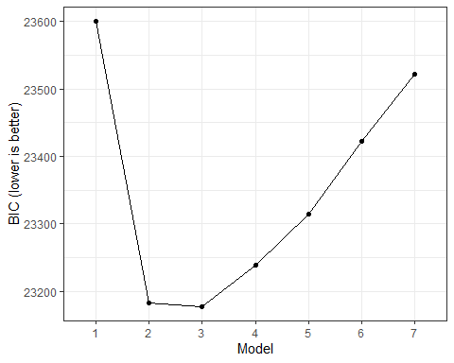

Table F2 shows how many participants are in which class in the three-class model.

**Table F2**

*Number of Participants Per Class in the Three-Class Model*

| Class | *N* assigned | Proportion assigned |
| --- | --- | --- |
| 1 | 381 | 30.2% |
| 2 | 314 | 24.8% |
| 3 | 568 | 45.0% |

## 2.2 Model Evaluation

Table F3 shows the different fit indices for the different numbers of classes.

**Table F3**

*Fit Indices for Different Numbers of Classes*

| Number of classes | LogLikelihood | *N* | Parameters | BIC | Entropy | Min prob | Max prob | Min *n* | NP ratio | Local NP |
| --- | --- | --- | --- | --- | --- | --- | --- | --- | --- | --- |
| 1 | -11,735.05 | 1,420 | 18 | 23,600.76 | 1.00 | 1.00 | 1.00 | 1.00 | 78.89 | 78.89 |
| 2 | -11,457.01 | 1,420 | 37 | 23,182.58 | 0.63 | 0.88 | 0.90 | 0.46 | 38.38 | 36.22 |
| 3 | -11,385.34 | 1,420 | 56 | 23,177.16 | 0.62 | 0.69 | 0.86 | 0.20 | 25.36 | 15.50 |
| 4 | -11,347.35 | 1,420 | 75 | 23,239.08 | 0.62 | 0.61 | 0.84 | 0.10 | 18.93 | 8.17 |
| 5 | -11,316.24 | 1,420 | 94 | 23,314.76 | 0.63 | 0.64 | 0.84 | 0.11 | 15.11 | 8.39 |
| 6 | -11,301.20 | 1,420 | 113 | 23,422.59 | 0.62 | 0.67 | 0.78 | 0.05 | 12.57 | 3.72 |
| 7 | -11,282.23 | 1,420 | 132 | 23,522.56 | 0.67 | 0.60 | 0.95 | 0.05 | 10.76 | 3.72 |

*Note.* BIC = Bayesian information criterion. Entropy = inverse entropy. Min/Max prob = minimum/maximum values (respectively) on the diagonal of the table of average posterior probabilities by most likely class membership (the higher these values, the better the model fit; recommended cut-off = .7; Masyn, 2013; Nylund-Gibson & Choi, 2018). Min *n* = proportion of participants that are assigned to the smallest class. NP ratio = how many observations are accessible for each parameter estimation on average (Van Lissa et al., 2023). Local NP = number of cases per parameter in the smallest class (indicates how much data there are for each parameter).

## 2.3 Model Interpretation

Table F4 and Figure F3 show the conditional item probabilities for the three-class model.

**Table F4**

*Conditional Item Probabilities per Category and Class*

| Variable | Category | Class 1 | Class 2 | Class 3 |
| --- | --- | --- | --- | --- |
| Sex drive | 1 | 0.16 | 0.32 | 0.49 |
| Sex drive | 2 | 0.16 | 0.28 | 0.18 |
| Sex drive | 3 | 0.37 | 0.24 | 0.23 |
| Sex drive | 4 | 0.31 | 0.16 | 0.11 |
| Mating effort | 1 | 0.03 | 0.26 | 0.37 |
| Mating effort | 2 | 0.17 | 0.24 | 0.35 |
| Mating effort | 3 | 0.35 | 0.30 | 0.20 |
| Mating effort | 4 | 0.44 | 0.20 | 0.07 |
| Social anxiety | 1 | 0.40 | 0.63 | 0.00 |
| Social anxiety | 2 | 0.18 | 0.17 | 0.20 |
| Social anxiety | 3 | 0.28 | 0.17 | 0.39 |
| Social anxiety | 4 | 0.14 | 0.03 | 0.41 |
| Loneliness | 1 | 0.29 | 0.54 | 0.05 |
| Loneliness | 2 | 0.27 | 0.28 | 0.14 |
| Loneliness | 3 | 0.26 | 0.14 | 0.33 |
| Loneliness | 4 | 0.19 | 0.04 | 0.49 |
| Mate value | 1 | 0.16 | 0.15 | 0.47 |
| Mate value | 2 | 0.25 | 0.28 | 0.27 |
| Mate value | 3 | 0.23 | 0.25 | 0.16 |
| Mate value | 4 | 0.36 | 0.32 | 0.09 |
| Attraction to children | 1 | 0.96 | 1.00 | 0.99 |
| Attraction to children | 2 | 0.04 | 0.00 | 0.01 |
| Compulsive sex. | 1 | 0.08 | 0.69 | 0.52 |
| Compulsive sex. | 2 | 0.92 | 0.31 | 0.48 |
| Probl. porn use | 1 | 0.30 | 0.75 | 0.61 |
| Probl. porn use | 2 | 0.70 | 0.25 | 0.39 |

**Figure F3**

*Conditional Item Probabilities per Class*

The classes look very similar to those for the male participants. Class 1 is similar to the “high risk” class, class 2 is similar to the “high mate value” class, and class 3 is similar to the “social incompetence” class.

# 3. Distal Outcomes Analyses

Predicted class 1 was chosen as the reference class because it can be interpreted as the “high risk” class. Table F5 and Figure F4 show odds and odds ratios (ORs) for all proclivity items per class.

**Table F5**

*Odds Ratios for All Proclivity Measures*

|  | Global LRT | (Intercept) | | Class 2 (“high mate value”) | | Class 3 (“social incompetence) | |
| --- | --- | --- | --- | --- | --- | --- | --- |
| Proclivity | *p* | Odds | *p* | OR | *p* | OR | *p* |
| Engaging in sexual activity with a prostitute | < .001 | 0.42 | < .001 | 0.31 | < .001 | 0.66 | .004 |
| Watching porn in public spaces such as a bus or library | < .001 | 0.45 | < .001 | 0.27 | < .001 | 0.43 | < .001 |
| Engaging in sexual activity with an adult who does not agree or is not able to agree, for example, due to intoxication | .006 | 0.04 | < .001 | 0.30 | .002 | 0.68 | .243 |
| Engaging in sexual activity with an animal | .006 | 0.02 | < .001 | 0.17 | .004 | 0.21 | .011 |
| Watching porn depicting a child | .001 | 0.02 | < .001 | 0.09 | < .001 | 0.40 | .062 |
| Watching porn depicting a child on the Darknet | .012 | 0.02 | < .001 | 0.12 | .003 | 0.35 | .076 |
| Flirting or having sexual conversations via chat or webcam with a child | .383 | 0.01 | < .001 | 0.46 | .247 | 0.40 | .204 |
| Paying or giving gifts to a child for online sexual material (for example, videos, images, or online streaming) | .294 | 0.00 | < .001 | 0.14 | .157 | 0.18 | .211 |
| Having offline sex or sexual contact with a child | .056 | 0.01 | < .001 | 0.08 | .034 | 0.10 | .055 |
| Watching porn depicting a young person | < .001 | 0.10 | < .001 | 0.28 | < .001 | 0.68 | .106 |
| Flirting or having sexual conversations via chat or webcam with a young person | < .001 | 0.11 | < .001 | 0.34 | < .001 | 0.67 | .080 |
| Paying or giving gifts to a young person for online sexual material (for example, videos, images, or online streaming | .159 | 0.01 | < .001 | 0.33 | .122 | 0.24 | .078 |
| Having offline sex or sexual contact with a young person | .004 | 0.13 | < .001 | 0.50 | .001 | 0.77 | .205 |
| Driving faster than the posted speed limit | .598 | 18.64 | < .001 | 0.86 | .557 | 0.76 | .311 |
| Driving under the influence of drugs/alcohol | < .001 | 1.30 | .007 | 0.47 | < .001 | 0.52 | < .001 |
| Robbing a bank | < .001 | 2.20 | < .001 | 0.51 | < .001 | 0.63 | < .001 |
| Killing someone | < .001 | 0.36 | < .001 | 0.35 | < .001 | 0.90 | .443 |

*Note.* Global LRT shows the *p* value of a test of the full against an intercept-only model. Penalised LRTs were used to obtain *p* values. Confidence intervals are not included because they would have been less reliable than *p* values.

**Figure F4**

*Odds for the Proclivities for Atypical (Sexual) Behaviours per Predicted Class*

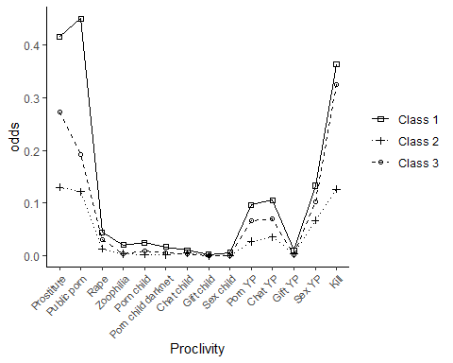

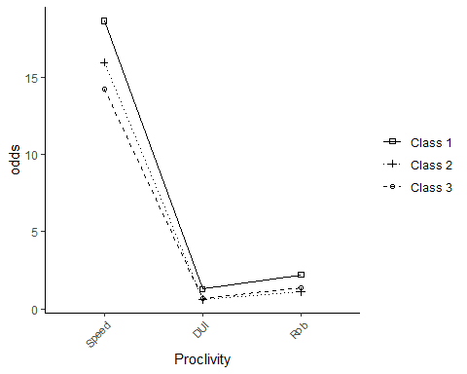

*Note.* Prostitute = “Engaging in sexual activity with a prostitute”; Public porn = “Watching porn in public spaces such as a bus or library”, Rape = “Engaging in sexual activity with an adult who does not agree or is not able to agree, for example, due to intoxication”, Zoophilia = “Engaging in sexual activity with an animal”, Porn child = “Watching porn depicting a child”, Porn child darknet = “Watching porn depicting a child on the Darknet”, Chat child = “Flirting or having sexual conversations via chat or webcam with a child”, Gift child = “Paying or giving gifts to a child for online sexual material (for example, videos, images, or online streaming)”, Sex child = “Having offline sex or sexual contact with a child”, Porn YP = “Watching porn depicting a young person”, Chat YP = “Flirting or having sexual conversations via chat or webcam with a young person”, Gift YP = “Paying or giving gifts to a young person for online sexual material (for example, videos, images, or online streaming”, Sex YP = “Having offline sex or sexual contact with a young person”, Kill = “Killing someone”, Speed = “Driving faster than the posted speed limit”, DUI = “Driving under the influence of drugs/alcohol”, Rob = “Robbing a bank”